Interface electrode/electrolyte
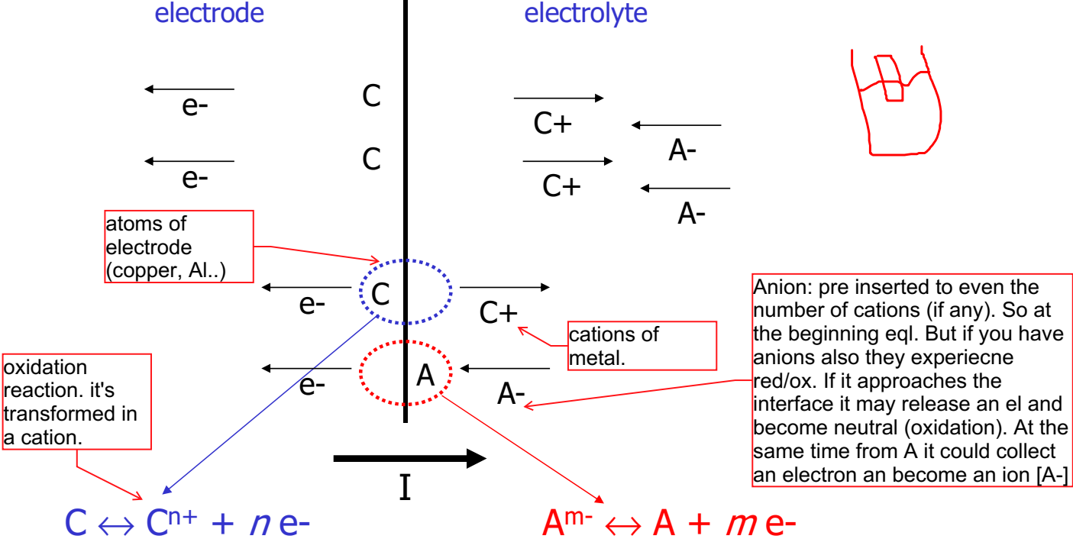
Key point: interface between electrode/tissue. In particular electrode/electrolyte. The tissue is considered like that.
Basic interface of batteries. When we perform an interface elt/elytr the most simple case: piece of metal(electrode) in water (electrolyte). What happen when they are put in contact?
Metal+electrolyte => oxidation reaction (we form a cation). The cation is released in the electrolyte. We may have the opposite reaction (cation already existing in the electrolyte) => reduction: the cation collects electrons from the metal, and they return to be neutral. In the equilibrium status, in average, same number of oxidation/reduction.
We have 2 extreme cases: the flow depends on the initial condition
- with an electrolyte at the beginning empty of cations, is probable that as soon as you put the metal you get oxidation
- If the electrolyte is full of cations, for charge neutrality you should also have an even number of anions. We may have a non-equilibrium: current flowing.
Non equilibrium: How can current flow? It means that you have oxidation. Cations generated and moving to the right. Anion moving to the left, and electrons moving to the left. (e.g. of the image).
Example.
1.) Electrolyte fully empty. First time you push the metal.
You'll have oxidation, because there are no CATIONS in the solution. So oxidation => release of cations in the electrolyte. How much will it last? For each cation generated (close to the metal) and an electron inside the metal.
- - - - - - - - -
_________________ surface
+ + + + + +

they attract each other. we have again a phenomena of double layer of charge. It creates a potential difference called SEMI-ELEMENT potential, which is the potential difference that grows across the surface due to the oxidation. Once it reaches a given value it stops the oxidation! It's "no more convenient from a concentration point of view". Similar to resting potential. You end up in equilibrium.
Semi-element potential => characteristic build in potential of electrode/electrolyte.
So: IN CONTACT YOU DON'T HAVE 0 ddp!!
You have a dV which is THEN stable, after the transient. It doesn’t have always this polarity.. it depends.
Example 2.)
We have heavily loaded the electrolyte solution with cations. You'll have also the same number of ANIONS.
There's no interest now for the metal to do an oxidation. The cations approach the metal and experience REDUCTION.
Now at the interface:

+ + + + + + + + (positive charges, we took el. from the metal to give to the cations)
__________________
C C C C C C C (neutral, they have collected an electron)
A- A- A- A- A- A-
There are unshielded anions, there's no BALANCE! we have uncompensated anions! Again double layer
Conclusion: we have a negative ddp. There's no universal rule, the semi-element potential may change. It may change sign, intensity, and primarily it depends on initial concentration of cations.

